Background and Literature Review

2.1- Overview
In previous chapter we discussed the introduction of our project, the ideology and aims for developing this project, and how this report will cover different aspects of the system. In this chapter we provide some explanation of the technologies used in project.

2.2- Introduction to CTI

Computer telephony integration (CTI), the technique of coordinating the actions of telephone and computer systems, has existed in a commercial form since the mid-1980s [1]. At first its application was largely confined to a few place markets, in particular call centres but recent developments have simplified computer-telephone systems significantly, leading to an increased interest in CTI applications for the mass market.
CTI (Computer Telephony Integration) combines information and telecommunications technology in one application. CTI simplifies many of the business processes and functions where the telephone plays an important role. For example caller identification via pop-ups on the PC screen, control of telephone functions over the PC. Direct dialing from a phonebook stored in the PC. Call planning and call reminders. Log book and call statistics and lots more.

2.2.1- CTI Benefits
- Increased efficiency through integration of telephone functions in the workflow
- Cost savings through the use of standard telephones rather than high-value feature phones
- Comfortable telephone operation over the PC
2.2.2- CTI Functions
CTI was developed to utilize computer intelligence to manage telephone calls. For example, CTI provides a better user interface compared with the traditional telephone interfaces that merely offer limited access methods through keypads. Furthermore, CTI provides platforms and functions that allow quick deployment for flexible telephone services. The CTI functions can be classified into three categories: call control, media processing, and customer data management.

Call control functions include:
- Call setup and release-related services such as dialing services and screening services.
- Routing-related services such as automatic attendant services and alternative routing services.
- Network interfacing services such as tone detection/generation, call setup/release detection, and in-band signaling detection.
Media processing includes:
- Voice/fax processing such as voice recording/announcement, voice and fax sending, broadcasting, storing and forwarding.
- DTMF (dual tone multi-frequency) digit processing, text-to-speech synthesis and speech recognition (such as spoken command recognition, speaker verification, voice cut-through and word spotting).
- Call logging such as on-line recording/monitoring and call accounting.
Customer data management
Customer data management provides personal information management for call parties. This management utilizes calling/called identifications to retrieve the calling/called party information from the database and associate the information with the call during its life so the call can be processed in an efficient manner. The information contained in the database may include a personal phone book, schedule, customer profiles, billing records, and so on.

2.3- TAPI & Telephony

Windows has made the application programmers’ job a lot easier by abstracting hardware devices, for example as regards to video cards and printers. In the old DOS days application programmers had to include support within their application for every printer model and every video card that the author wished to support. So an application used to come with many video and printer drivers all written by the application programmer specially for that application [2].
With the advent of Windows the hardware manufacturer of the printers and video cards all write a single driver for each device ensuring that it conforms to a particular Microsoft API specification that concerns such things as hardware capability discovery and a common command set. The application programmer then uses the API to read and write from the hardware, the API sits between the application and the hardware offering this uniform interface whatever the hardware, its connection method and its capabilities.
TAPI was developed jointly by Intel and Microsoft and is the API set for Telephony, including modems and other communications devices. You can write a telephony application without the need to know about the specific hardware details for example the modem chip set commands, serial\parallel port or USB all should make no difference if your application is using TAPI and the hardware device has a TAPI driver called a TSP (Telephone Service Provider) All of this relies on the hardware manufacturer writing a TSP for his devices [2].
TAPI is quite complex APIs to use hence the value of using third-party TAPI controls increases. Though programmer can utilize TAPI more affectively and with lots of advantage but the main problem is that using TAPI for an application is going to be a complex task. In fact making controls of TAPI itself is a considerable project. So according to need of application, programmer can utilize any third-party TAPI control that suits his application without solving the complexities of TAPI.

2.3.1- Advantages of TAPI Based Applications
The major advantages of using TAPI are:
- Programmer does not need to write device level code for particular devices, as long as device is TAPI compliant.
- Customers are not restricted by the hardware that application supports, as long as the hardware has a TAPI TSP then any hardware will work with application.
- Modification in application to handle new hardware or new technologies as they appear on the market is easy. As long as the new devices have a TAPI TSP your application will still operate correctly.
Many commercial programs do not use TAPI and suffer disadvantages as a consequence, non TAPI compliant programs need a database of configuration and command specific information for all supported telephony devices and consequently can never be up to date and support the very latest devices.
Non TAPI compliant programs are unable to share telephony devices, even the simplest of customer requirements using every day hardware suffer the consequences of non TAPI compliant applications. Take for example a customers need for a simple answering machine application using a voice modem, then consider the customers second need to make outgoing calls with for example Dial up Networking for Internet connection. Before using the Internet the answering machine has to be closed, remembering to run the answering machine after closing the Internet connection. Sure you could construct an application to meet this need without TAPI but this restricts the users from being able to mix and match telephony application to meet his wants and needs [2].

2.3.2- The Telephone Network

Most domestic properties and many small businesses are connected to the telephone companies CO "Central Office" via a POTS line [2], a two core balanced line cable, this part of the telephone network is often referred to as the "Local Loop" and is usually less than 1 mile long. The design of the Local Loop has not changed much since the day the telephone was invented.
POTS simply stands for Plain Old Telephone System which is an analog system, the name POTS is used to distinguish it from the modern digital telephone system that medium sized to large businesses are using today. In the future all telephone communications will be by digital systems but the cost of replacing the millions of 1 mile Local Loop cables with say, a fiber-optic cable capable of digital transmission is prohibitive so most of us have to put with the old POTS system.

2.3.3- Incoming call

When the CO wants to signal to the receiving telephone set an incoming call the CO applies a pulsing ring pattern of 70 volt AC "Alternating Current" to the local loop which causes the telephone bell to ring.
When you answer the telephone by lifting the receiver you complete the DC circuit causing an increase in the DC current that is being supplied from the CO, the CO detects this increase in DC current, this is the signal to the CO to stop the ringing voltage and connect the call by switching (you will often hear the term Switch, meaning the telephone exchange) the voice circuit to the calling party.
The duplex (both directions at the same time) AC audio is transmitted at fairly low levels on top of the 50 volt DC supply. A telephone conversation can then ensue, when you hang up (replace the handset) the DC current to the CO drops signaling to the CO the end of the call, the CO then signals to the other party the end of the call using Loop Disconnect (pulsing the DC current off for a few hundred milliseconds) and depending on the telephone company may also apply a rapid busy tone to the line.

2.3.4- Outgoing Call

When you make an outgoing call you lift the handset (going off-hook, referring to the switch that turns on when you lift the handset, years ago the handset would have been stowed on a hook hence off-hook meaning when you lift it off the hook, you will also hear the term switch hook) this signals to the CO by increasing the DC current that you want to make a call, the CO will immediately respond by applying dial tone to the line so that you understand that the CO is ready to receive the telephone number of the party you want to dial.
If you have an old fashioned telephone set you will literally dial the number. For each digit of the number that you "dial" the telephone will pulse the DC supply the appropriate number of times for the digit dialed, for example dial the number six and the DC current is interrupted six times, dialing 0 gives 10 pulses. The CO counts these pulses detecting the inter-digit pause to build the telephone number (also called the address) of the party you want to call.
Nowadays modern telephones do not have a dial and uses a different method of signaling the telephone number to the CO. The modern signaling method is called DTMF (dual-tone multi-frequency), every time you press one of the numbered button keys on your telephone two (hence the dual-tone) audio frequency tones are applied simultaneously on top of the DC voltage on the local loop telephone line. Each button key on your telephone generates a different combination of dual tones.
Whichever method is used for signaling (CO's still today support both methods) the CO receives the telephone number of the party you want to call and the remote 'switch' applies the ringing voltage to the called party local loop. While you are waiting for an answer the CO sends back to you an audio tone called ring-back to indicate that the call was successful and you are just waiting for an answer.
When the call is answered you do not get any tone, or change in DC current, instead it is customary when answering a telephone to signal to the calling party by saying hello or announce your telephone number with plain human speech. If the called party was already using the telephone then the CO returns an audio tone called busy tone to you to indicate that you should hang-up (go on-hook) and try again later[3].

2.3.5- POTS Lines

A standard POTS line has a very limited bandwidth about 3 kHz just about enough bandwidth for the transmission of tolerable quality speech audio, the problem we have today is we are attempting to use the POTS analog telephone system for such things as Internet connections, trying to squeeze high speed digital data down an analog cable that only has a 3 kHz bandwidth.

This impossible task is done by our modem (Modulator Demodulator) using all the tricks known to man we can just about get a 56,000 bits per second digital signal down that old POTS system, a remarkable achievement by the modem manufacturers even bearing in mind that the practical maximum speed is 48, 000 bits per second and then only when one end of the call has a digital connection. These speeds are only achieved in the download direction, the maximum upload speed is 33,600 bits per second. Many people don't realize that if you connect two 56k modems together over the POTS telephone system that the maximum transmission rate is only 33,600 baud (baud meaning bits per second) To get the 56k baud rate one end needs to be connected digitally, for example the Internet Service Provider.

2.4- TAPI Compliant Telephony Devices

Whatever the type of telephone line digital or analog you will need some sort of adapter to connect the lines to a computer, you will also need a TAPI TSP. This could be an ISDN terminal adapter, a Telephony Board or a modem.
Of course the main advantage of digital connections is the wider bandwidth, but that is not the only significant advantage. Call progress detection is far more reliable with digital connections and that is certainly significant when you are writing automated telephony applications.
Professional Telephony boards are available for both digital and analog lines and even the analog telephony boards can do a reasonable job of call progress detection, except that they have to be configured for the particular country in which they are used. The analog tone signaling specification varies considerably between countries, there is no real international standard.
Modems are for use with POTS analog lines and if you attempt to use low cost voice modems for automated telephony applications you will have to deal with the severe limitations of their call progress detection. Of course the cost of voice modems in comparison to telephony boards means that depending on your target market you may have to accept and work within the limitations that voice modems have. If your project can stand the extra cost then there is no contest, use a professional telephony board.
Other TAPI compliant devices are available, for example some telephone sets have a TAPI TSP available and many digital and analog telephone exchanges can be interfaced using TAPI.

2.5- Voice Modems

Microsoft wrote a TSP called unimodem (a universal modem driver) and later a voice capable version unimodemV. Unimodem and UnimodemV are configurable with an inf file during modem installation but because Unimodem was designed to work with any modem it has severe limitations [2].
Because Microsoft wrote this universal modem driver most manufacturers take the easy way out and use it, configure it with an inf file and suffer the inherent limitations of Unimodem rather than writing their own TSP that would be able to use all of the capabilities of their hardware.
A further problem is that Microsoft did not supply a voice enabled version of unimodem for Win NT, meaning that voice modems will not support TAPI under NT4. Most modem manufacturers supply voice software with the modem that does not use TAPI and has been configured specifically for their modems command set and capabilities. So you will find voice capable applications using voice modems, running under NT4, but not via TAPI. Fortunately Microsoft have provided a voice enabled TSP for Windows 2000 and Windows XP called unimodem 5.

2.5.1- Limitations of Voice Modems

Voice modems vary considerably in quality as far as voice functions are concerned, the situation for data and fax communications is much better. Data and fax communications with modems tends to be reliable and have few significant limitations apart from speed. After all modems were originally designed for data and fax applications, voice functionality has been added to some modem models just as an extra sales feature rather than as a primary function. The quality of different modem models from the same manufacturer can also vary from good to very poor and as the manufacturers seem to change their models on such a regular basis, this it makes it very difficult to recommend the best modems to use.
The main limitations are:
- Poor audio quality, varies from poor to acceptable.
- Long initial startup delays when playing and recording, varies from acceptable to sometimes seconds!!
- Often no volume or gain control on the line audio
- Unreliable DTMF tone detection, needed for IVR (Interactive Voice Response) applications.
- No ring back signaling
- Unreliable busy detection, depends on the country the modem was principally designed for. Usually the USA.
- Modems signal connected immediately after dialing is completed, before the call is answered and even if the call is busy. If the call is busy and luck is on your side after the connected signal you will receive a busy signal.
- Unreliable or non-existent remote party hang-up signaling. Modems can not detect the Loop Disconnect hang-up signal of standard POTS CO's. Only if the CO also sends rapid busy can the modem detect that the remote party has disconnected and even then only if the modem can detect that particular rapid busy tone.
- Caller ID standards vary from country to country, modems often only support the US standard.
- Lack of Phone devices, about 50% of voice modems on the market support a speaker phone device but as far as I am aware no modems support "Handset" or "Headset" devices. Handset is the term TAPI uses for a normal local telephone set. See TAPI Phone Devices described later.
- Most modems have a socket where you connect a local telephone but this phone cannot be controlled or monitored in any way by the application. The application is not able to detect when the handset is lifted or replaced. The application cannot control the speech path or play or record audio from the handset and some modems even disconnect the local phone when the modem is off-hook.
- Other problems with some modems are for example, the line dropping after a wave file has been played, DTMF [2] detection failing after a wave file has been played etc. These sorts of problems are actual faults with the modem or inf file, you should complain to the modem supplier.
- Modems often have an incorrectly configured inf file supplied by the manufacturer. See below for more details.
One of the important advantages of TAPI is the ability of an application to determine the capabilities of the modem dynamically. The application can request from the TSP the capabilities of the modem. Do you support a "Speaker Phone", do you support a "Headset" etc. this allows the application to adapt itself depending on the modems supported feature set.
Modems use Microsoft's unimodemV as their TSP, unimodemV is configured during installation by the inf file supplied by the modem manufacturers. Many inf files are incorrectly configured by the manufacturer, they often indicate capabilities that the modem does not have, there is no excuse for this, if this happens to you then consult the manufacturer [2].

2.6- TAPI Phone Devices

TAPI supports three types of phone devices, that is to say a device that can be taken off hook or placed on hook by the users and has a microphone and speaker or earphone. The supported devices are:
- Handset, something you would recognize as a traditional telephone set.
- Speakerphone, a loud speaking telephone set used for hands free calls. Not suitable for use in shared or noisy environments.
- Headset, used for hands free calls, convenient for people spending long periods of time communicating by telephone.
TAPI allows an application to monitor and control elements of the phone device, signaling when a phone device is bought into use, for example when the handset is lifted (hook switch signal) etc. An application can also switch the audio circuits of the phone device to the line or allow the voice path to be used as an I/O device for recording and playback. An application may also be able to adjust audio gain and volume levels and monitor phone buttons.
All of these features are supported by TAPI but obviously depend upon the telephony hardware and the TSP capabilities. An application can request from the TSP the capabilities of the telephony device. Do you support a "Speaker Phone", do you support a "Headset" etc. this allows the application to adapt itself depending on the supported feature set.

2.7- amTapi Pro

amTapi Pro [5] is an ActiveX control that can be incorporated in to applications to make and answer voice or data calls, detect Caller ID on incoming calls, detect remote party DTMF key press tones, generate DTMF tones etc. amTapi is TAPI (Microsoft and Intel Telephony API) compliant. We have put together a simplistic overview of TAPI, it's connectivity models, TAPI drivers or TSP's as they are called and a description of first-party/third-party call control, that may be of help to those of you that are new to TAPI and Telephony.
amTapi Pro abstracts TAPI to a simple telephone object that can be easily controlled by your application, it also allows your application to auto discover the capabilities of the available hardware telephony device and adapt itself accordingly. amTapi can be used with all TAPI compliant telephony hardware, including low cost modems, professional multi-line telephony cards, compliant ISDN adapters, switches and telephone instruments etc.
Written in C++ using ATL Active Template Library, amTapi is lightweight with no dependencies and can be used on Windows 98, Windows ME, Windows NT 4, Windows 2000 and Windows XP.
As an ActiveX control amTapi can be used in the many development environments that support ActiveX controls, including Visual Basic, Visual C++ and Microsoft's Office products etc. amTapi is available in three versions, Lite, Professional and Enterprise; dot.NET versions will be available in the future.
The only requirements for using amTapi are:
- Windows OS, Windows 98 or later.
- A Development environment that supports ActiveX controls
- TAPI compliant telephony device and TSP (TAPI driver) If you intend to use a modem for voice functions be sure to read the section Voice Modems in the TAPI & Telephony section of this help file.

2.8- amWave Pro

The Allen-Martin amWave Pro [4] control is a general purpose wave audio control that can be used to play and record audio files in mono or stereo for all formats for which an associated Windows ACM (Audio Compression Manager) codec is installed on the PC, including PCM, RIFF-MP3, ADPCM, GSM, CCIT A Law and µ Law, True Speech(TM), etc. as long as the appropriate codec is installed. Playback and recording is available for all wave devices installed on the PC.
The amWave Pro control also has the capability to convert audio files from one audio format to another audio format as a background task.
Each instance of amWave Pro can simultaneously play, record and convert audio files. Multiple instances of amWave Pro can be instantiated giving the ability to play, record and convert multiple files simultaneously, the only restricting factor in the number of simultaneous play\record\convert streams is the speed of the PC.
Memory requirements are kept to a minimum by streaming the wave audio directly to\from the hard disk drive, audio files are limited in length only by the hard disk size. amWave Pro uses double buffering of the audio to ensure no breaks in the audio are caused by the multitasking nature of Windows.
The amWave Pro control can be used in conjunction with the Allen-Martin telephony controls amTapi for playback and recording from telephony devices.
Written in C++ using ATL Active Template Library, amWave is lightweight with no dependencies and can be used on Windows 9x, Windows ME, Windows NT 4, Windows 2000 and Windows XP.
As an ActiveX control amWave can be used in the many development environments that support ActiveX controls, including Visual Basic, Visual C++ and Microsoft's Office products etc.
The only requirements for using amWave Pro are:
- Windows OS, Windows 95 or later.
- A Development environment that supports ActiveX controls
- Optional amTapi control.
- Optional a telephony device of some type if you are using amTapi.

2.9- Microcontroller

2.9.1- Introduction

A microcontroller is an integrated circuit (IC) that is programmable. When you turn on the power to the microcontroller it goes through a series of commands. These commands are put in the chip by you. You can make it do different things by changing the commands (usually called the program).
To program a microcontroller, you must use a language. In past, assembly language is used but now C language is also introduced which make work more easier.
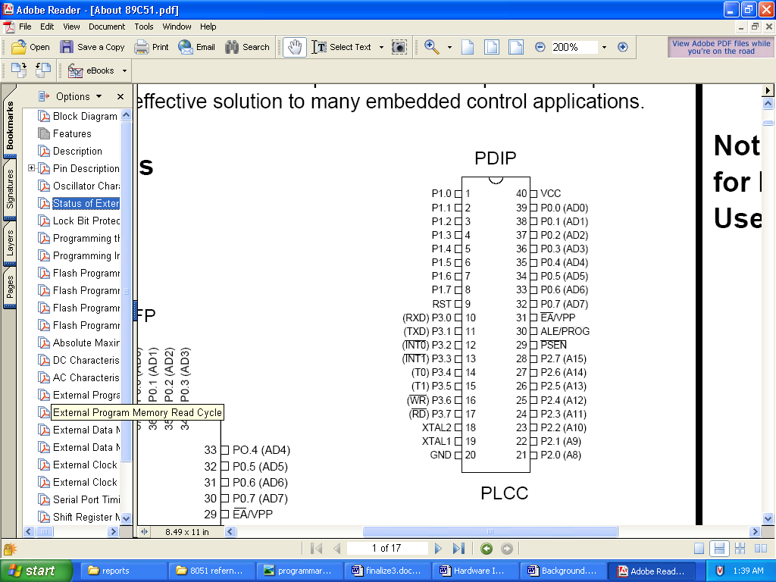
Fig 2.1 89c51 Microcontroller Pin Diagram

2.9.2- Microcontroller Programmer

Microcontroller is programmed by using a programmer. There are many programmers available. We can make our own programmer. Below is a figure of a programmer circuitry that helps to burn a microcontroller.

Fig 2.2: 89c51 Microcontroller Programmer

2.9.3- Inpout.dll

It’s a dynamic link library file which allows Visual Basic to interact with parallel port to retrieve data. It has only two functions Inp32 and Out32 for input and output the data. It can be easily used with VC++ too

2.9.4- Ride C Compiler
It’s a compiler which helps to program the microcontroller in C language. Its syntax is similar to C language for PC.
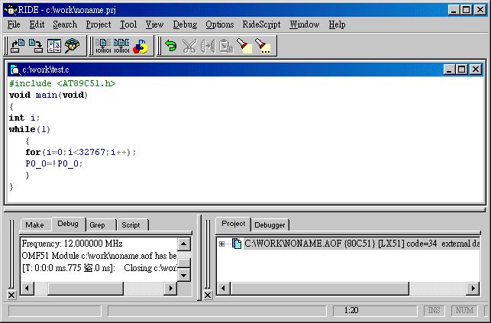

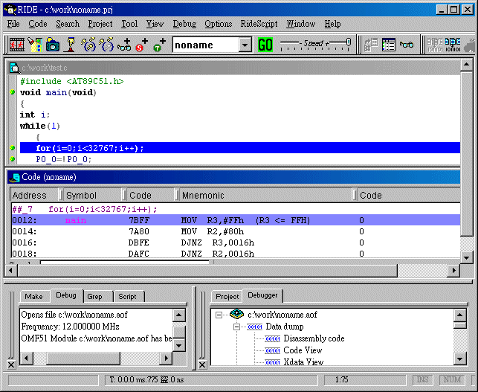
Fig 2.3 Ride C Compiler GUI

2.10-Relays

A relay is an electrically operated switch. Current flowing through the coil of the relay creates a magnetic field which attracts a lever and changes the switch contacts. The coil current can be on or off so relays have two switch positions and they are double throw (changeover) switches.
Relays allow one circuit to switch a second circuit which can be completely separate from the first. For example a low voltage battery circuit can use a relay to switch a 230V AC mains circuit. There is no electrical connection inside the relay between the two circuits, the link is magnetic and mechanical.
The coil of a relay passes a relatively large current, typically 30mA for a 12V relay, but it can be as much as 100mA for relays designed to operate from lower voltages. Most ICs (chips) cannot provide this current and a transistor is usually used to amplify the small IC current to the larger value required for the relay coil [9].
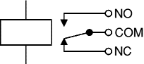
Figure 2.4: Circuit symbol for a relay
The relay's switch connections are usually labelled COM, NC and NO:
- COM = Common, always connect to this, it is the moving part of the switch.
- NC = Normally Closed, COM is connected to this when the relay coil is off.
- NO = Normally Open, COM is connected to this when the relay coil is on.

- Connect to COM and NO if you want the switched circuit to be on when the relay coil is on.
- Connect to COM and NC if you want the switched circuit to be on when the relay coil is off.

